**VIT-AP UNIVERSITY, ANDHRA PRADESH**

**Lab Sheet 2: Advanced CSS, Java Script**

Branch/ Class: B.Tech Date: 07-01-2026

Faculty Name: Prof. S.Gopikrishnan School: SCOPE

Student name: N Siddeswar Reg. no.: 23BCE9776

___________________________________________________________________________

**Exercise 1: HTML5 Canvas**

Create a web page that contains a <canvas> element.

The canvas must:

• Have a size of 500 × 300  
• Display a filled rectangle  
• Display a filled circle  
• Display a straight line  
• Display the text “HTML5 Canvas” inside the canvas  
• All shapes and text must be drawn using JavaScript

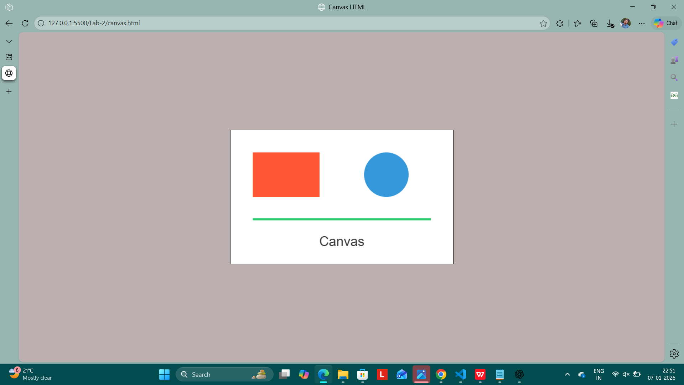

**Exercise 2: HTML5 Audio and Video**

Design a multimedia web page that contains:

• One audio player  
• One video player  
• Both players must include play, pause and volume controls  
• Display the current playing time dynamically  
• Add suitable headings for audio and video

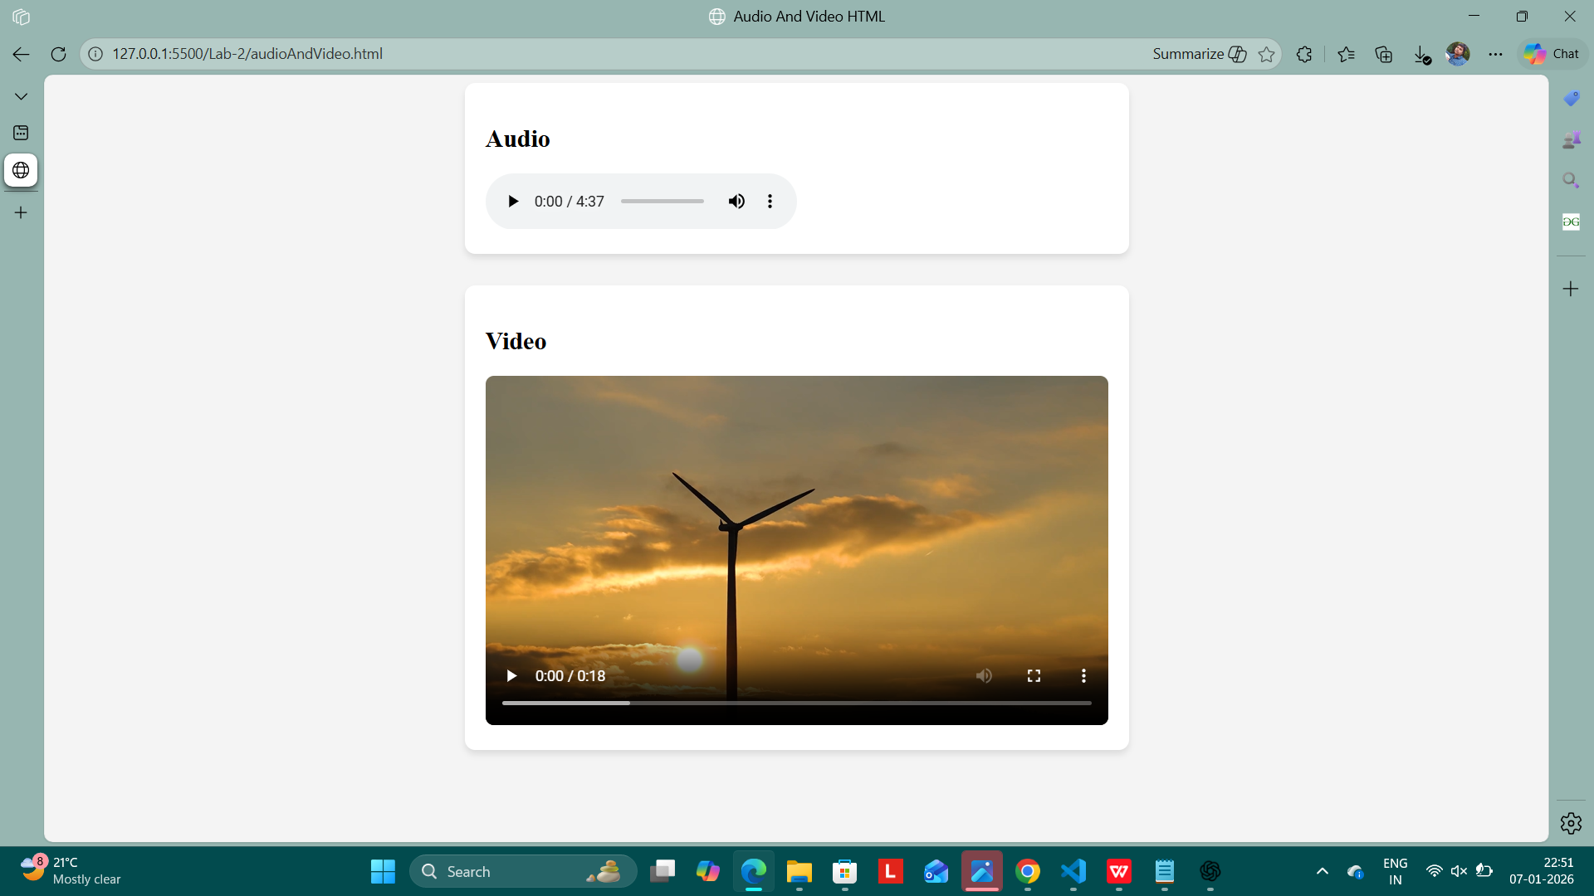

**Exercise 3: Advanced Drag and Drop Task Manager**

Create a mini task board using HTML, CSS and JavaScript.

The page must contain:

• A text box to enter task name  
• An Add Task button  
• Three task columns:

* To Do
* In Progress
* Completed

When the Add Task button is clicked:

• A new draggable task card must be created dynamically  
• The task card must display the task name and current date

Using Drag & Drop:

• Tasks must be draggable between the three columns  
• When a task is dropped into Completed:

* Change its background color
* Display a message “Task Completed Successfully”

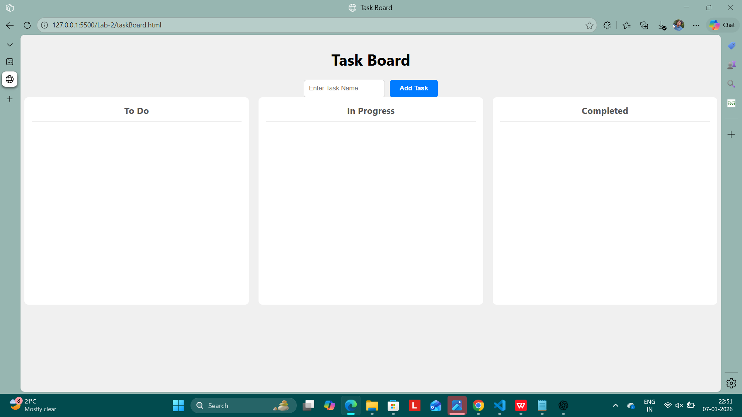

**Exercise 4: Advanced LocalStorage User Management System**

Design a User Registration & Management system using HTML, CSS and JavaScript.

The page must contain:

• Registration form with:

* Name
* Email
* Mobile Number
* Password

Validations:

• All fields must be mandatory  
• Mobile number must be 10 digits  
• Password must be minimum 6 characters

Functional Requirements:

• On Submit:

* Store all user details in localStorage as objects
* Do not allow duplicate email registrations

• Display Users:

* Show all registered users in a table format
* Provide a Delete button for each user
* On delete, remove the user from localStorage and update table

• Provide a Clear All Users button to erase complete storage

